

**BENAZIR BHUTTO SHAHEED UNIVERSITY LYARI**

**FYP PROPOSAL**

**(Brain Tumor Detection Using Convolutional Neural Network)**

**Group Members:**

* Salman Abdul Rahim (BCS616) [GL]
* Zain-Ul-Abideen (BCS637)
* Muhammad Mohsin (BCS592)

**Project Supervisor:**

Sir Ali Muhammad Amore

**TABLE OF CONTENTS**

1. CHAPTER-01:

* Abstract ………………………………………………………………………. 01
* Introduction …………………………………………………………………... 01
* Introduction To Project………………………………………………. 01
* Problem Statement…………………………………………………… 01
* Background Of Study………………………………………………... 02
* Objectives……………………………………………………………. 02
* Scope And Limitations………………………………………………. 02
* Motivations…………………………………………………………... 03
* Methodology …………………………………………………………………. 03
* Methodological Model………………………………………….......... 04
* Process Model………………………………………………………..
* Use Cases…………………………………………………………….
* Timeline……………………………………………………………...
* Conclusions …………………………………………………………………..
* Reference …………………………………………………………………….

**CHAPTER-01**

1. **ABSTRACT:**

Medical Image Processing has been a popular field for the research and project purpose these days. When talking about Tumor Extraction or the similar area, it has been noticed that the research is extremely active in the image processing of human brain for the successful tumor detection and analysis. Although, it becomes a challenge to rectify the critical examination of medical brain images, the newest technology and its capabilities pulls it through. In this Final Year Research Project, we have gathered main focus on the methodology which tends the automation of analysis regarding brain tumor to become effectively possible. For this, we are up to utilize the latest A.I technology followed by its revolutionary technique, Deep Learning. The data for the Tumor Detection consists of MR images of brain, halve of them containing tumor traces while others do not. After the completion of back-end process, it is all about the User Interface design that would be accomplished through developing an Android & iOS Application while applying all the back-end methodologies behind it. This application has been planned to be named as “Tumaria”.

1. **INTRODUCTION:**

* **Introduction To Project:**

Our Final Year Project is on one of the most demanding domain of this era, i.e. Artificial Intelligence. The main focus of the project is towards the advancement in the field of Tumor Pathology in the human brain. In this project, we shall use the MRI images of the brains, some of them containing tumor, while others do not. For the related research and implementation, we are up to use one of the best and renowned Neural Network Algorithm, i.e. Convolutional Neural Network (CNN). Moreover, all the work is aimed to be done using the Python Language.

For the usability of the system, there would be a proper Android and iOS Mobile Application which would be linked with an API containing our MR images’ trained model. In the end, we can say that the project is a perfect combo of front-end and back-end, giving prestige to the revolutionary technologies of Artificial Intelligence as well as Flutter UI Software Development.

* **Problem Statement:**

Detecting tumor in the complex and delicate organs of the human body is always a big challenge. For the tumor in human brain, the doctors and specialists have to go through deep examination of the MRI or the CT-scanned image. This surely takes too much time to get to some final conclusion. Even a tiny spot can make difference if got ignored. Through the automation process and brain tumor detection application, it would be far easier to execute the brain tumor examination.

* **Background Of Study:**

A brain tumor is a mass or growth of abnormal cells in your brain. It has different types and varying effects on the human body. Some brain tumors are benign i.e. they are non-cancerous while some are malignant i.e. they contain cancer. Generally, brain tumors arises in two different modes. A primary brain tumor originates initially in a human brain, whereas the secondary brain tumor (metastatic) is caused due to cancer present in other parts of your body. How quickly a brain tumor grows can vary greatly. The growth rate as well as location of a brain tumor determines how it will affect the function of your nervous system.

Primary brain tumors begin when normal cells acquire errors (mutations) in their DNA. These mutations allow cells to grow and divide at increased rates and to continue living when healthy cells would die. The result is a mass of abnormal cells, which forms a tumor.

Secondary (metastatic) brain tumors are tumors that result from cancer that starts elsewhere in your body and then spreads to your brain. Any cancer can spread to the brain, but the most common types include, Lung Cancer, Kidney Cancer, Breast Cancer, etc.

Moreover, there are two common factors due to which brain tumor can take place. One of them is exposure to radiations as these can be harmful to the entire body. The second factor is family history of genetic syndromes that increase the risk of brain tumors.

* **Objectives:**
* To contribute in the field of human brain pathology through developing an effective and automated tool in order to detect human brain tumor.
* To automatically detect brain tumor as we input the MR image of a patient’s brain.
* To create such an interface for the brain tumor detection system which is understandable and easily operable.
* **Scope And Limitations:**

Artificial Intelligence has turned out to be the best guardian for the field of medical. In order to carry out different image segmentations through its sophisticated methods, Artificial Intelligence has deployed a remarkable change for the surgeries that require image guidance. As in this project, we are focusing on the brain tumor analysis and detection, the deep learning models and image segmentation techniques shall make it possible to accomplish the needs in an efficient way, thus converting the manual image analysis into effective and improved automation.

It is obvious that when we work on a certain project, there are some limitations and hurdles that can put effect in our workflow and project goals. In this project, we are facing the following:

* + Limited number of dataset will be used for the experiment.
  + The proposed model will be justified through the Python language.
* **Motivations:**

Motivation for solving a problem matters a lot. The interest in undertaking challenges, different medical disease detections and classifications, exploring advanced Artificial Intelligence techniques, and the incident with a relative of one of our group members made us choose this unique research area.

This is surely the yet biggest opportunity for us to learn about the latest trends of the Medical Image Processing area. If we were in the medical field, we undoubtedly had worked up on the subject of Brain Tumor. But, now finally, it’s the chance for us to explore our interest and contribute in the field of Brain Tumor Examination.

1. **METHODOLOGY:**

* 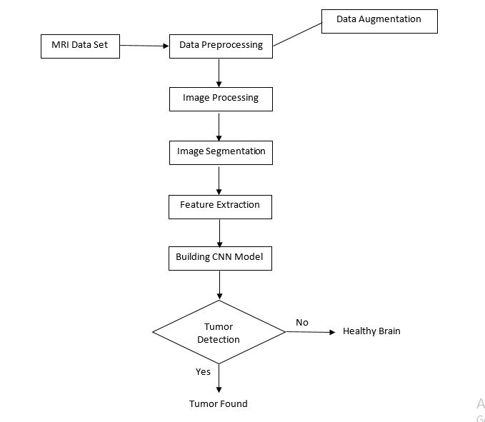**Methodological Model:**
* **Process Model:**
* **Use Cases:**
* **Timeline:**

1. **CONCLUSION:**
2. **REFERENCES:**

* <https://www.slideshare.net/Vivekreddy91/brain-tumor-detection-by-scanning-mri-images-using-filtering-techniques-79830026>
* <https://www.slideshare.net/esatjournals/brain-tumor-detection-and-segmentation-using-watershed-segmentation-and-morphological-operation-64962908>
* <https://www.researchgate.net/publication/333062321_Automatic_Human_Brain_Tumor_Detection_in_MRI_Image_Using_Template-Based_K_Means_and_Improved_Fuzzy_C_Means_Clustering_Algorithm>
* <https://arxiv.org/ftp/arxiv/papers/1809/1809.07786.pdf>
* <https://www.mayoclinic.org/diseases-conditions/brain-tumor/symptoms-causes/syc-20350084>